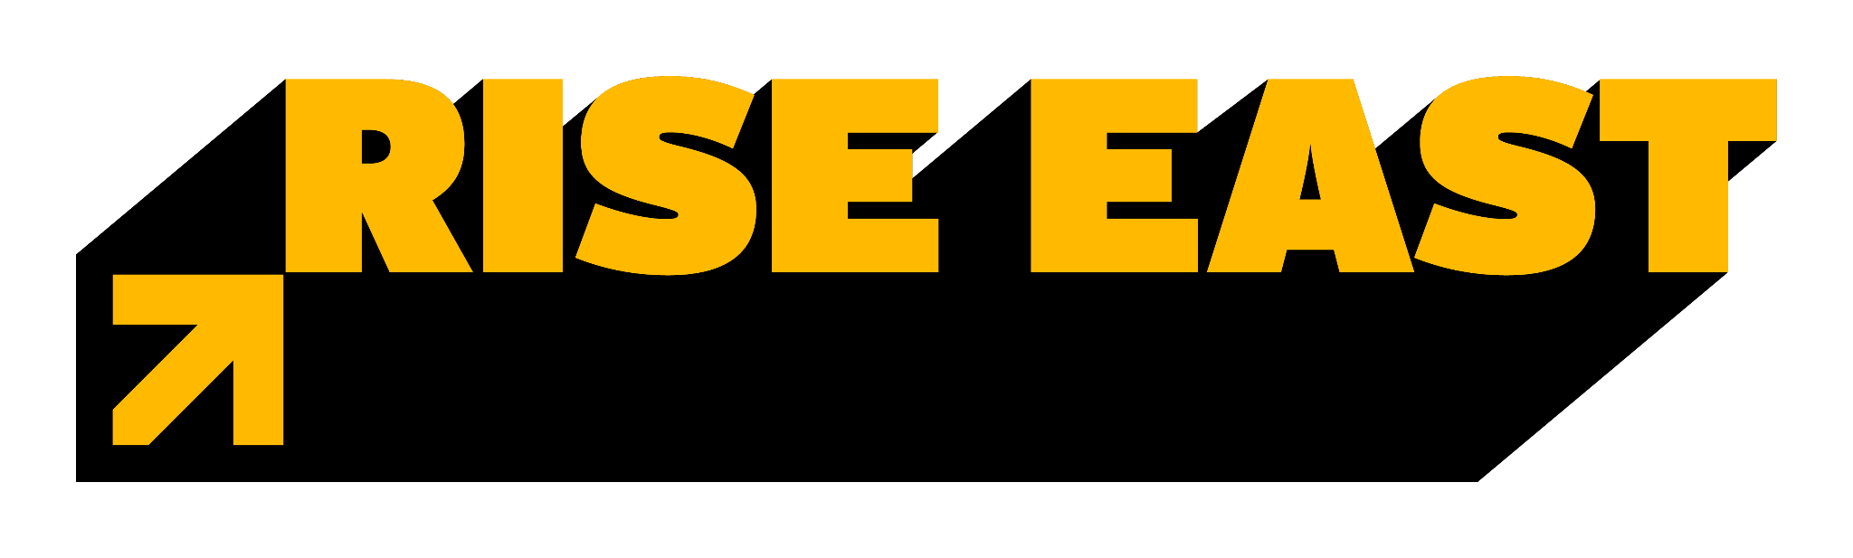
********MEDIA ADVISORY*********
Black Cultural Zone CDC and Rise East Launch Innovative Idea-A-Thon to Transform East Oakland
Oakland, CA – November 16, 2024 – Black Cultural Zone CDC and Rise East are thrilled to announce the launch of their groundbreaking Idea-A-Thon, a collaborative 3-day event designed to ignite innovation and address the pressing challenges facing East Oakland. This unique initiative invites creative minds from the Oakland community to come together to develop their visionary ideas for a more equitable and prosperous future.
Much like a “Hack-A-Thon,” the Idea-A-Thon will feature engaging activities, including training sessions, inspiring workshops, and a captivating weekend-long ideation marathon. Participants will have the extraordinary opportunity to network with like-minded individuals, learn from industry experts, and refine their innovative ideas into actionable solutions – specifically on how to revitalize the business corridor of International Ave. from 80th and 90th Streets.
MEDIA ARE INVITED TO ATTEND: Saturday Nov. 16, Noon to 1 PM.
LOCATION:
- Saturday- East Oakland Youth Development Center 8200 International Blvd. Oakland 94621
CONTACT: Ari Curry, 510-719-2618
Key Event Highlights:
- Empowering Training and Workshops: Participants will gain a valuable introduction to ideation, design thinking, and collaborative problem-solving, empowering them to tackle complex challenges.
- Inspiring Expert Panel Briefings: Industry leaders and community experts will share invaluable insights on various topics, including economic development, public safety, education, and healthcare, sparking new ideas and perspectives.
- Intense Ideation Marathon: A weekend-long immersive experience where participants will collaborate to develop groundbreaking solutions, fostering a sense of community and shared purpose.
- Thrilling Idea Pitch Competition: Finalists will present their innovative ideas to a distinguished panel of community judges and compete for exciting prizes, showcasing their talent and potential.
“We firmly believe that the power of collective intelligence can drive significant change,” said CJ, CEO of Black Cultural Zone CDC. “The Idea-A-Thon is an opportunity for individuals to contribute their unique perspectives and help shape the future of East Oakland, creating a more just and equitable community for all.”
November 1, 2024
Ide-A-Thon Virtual Training Modules
- Understanding the Ide-a-Thon
- Ideation Techniques
- Building a Collaborative Environment
- Understanding the Challenge

Week of November 4, 2024 :
Design Thinking Workshop
Lived Experience and Expert Panel Briefings person
- Lived Experience and Expert Panel Briefing: Live and Thrive
- Lived Experience and Expert Panel Briefing: Safe and Connected Briefing
- Lived Experience and Expert Panel Briefing: Power Building
- Lived Experience and Expert Panel Briefing: Learn and Grow
- Lived Experience and Expert Panel Briefing: Work and Wealth Building
- Lived Experience and Expert Panel Briefing: Family Health and Well-Being

Pre-Ide-A-Thon Activities: Week of November 11, 2024
- Corridor Tour(s)
- Brainstorming Session 1
- Pre-Weekend Idea Generation Session 2

Ide-A-Thon Weekend Activities
Friday, November 15, 2024 (5:00 pm until 9:00 pm - Dinner Served):
- Activity 1 - Kick-off and Brainstorming

Saturday, November 16, 2024 (11:00 am until 5:00 pm - Lunch, Refreshments and Dinner Served):
- Activity 2 - Idea Refinement and Development
- Activity 3 - Idea Prototyping

Sunday, November 17, 2024 (Noon until 6:00 pm - Lunch, Refreshments and Dinner Served):
- Activity 4 Idea Pitch Preparation
- Activity 5: Idea Presentations and Selection
- Ide-A-Thon Winning Group (s)

About Black Cultural Zone Community Development Corporation (BCZ CDC):
The Black Cultural Zone Community Development Corporation (BCZ CDC) is a dedicated non-profit organization committed to revitalizing East Oakland. Its mission is to foster economic development, preserve rich cultural heritage, and empower the community. Through a comprehensive approach that includes initiatives like the Market Hall and Liberation Park Residences, the BCZ CDC cultivates a thriving economic ecosystem that celebrates African and African American culture while ensuring the well-being of its residents.
About Rise East:
Rise East is a dynamic collective impact effort guided by a comprehensive 10-year plan. This initiative emerged from a community-led vision to develop a Black Cultural Zone in East Oakland. For over a decade, community leaders in East Oakland have laid the groundwork to bring this vision to life. The Rise East plan identifies core investable strategies to accelerate this transformative work over the next 10 years. Key to this place-based strategy is deep partnership and collaboration among community-based organizations, community members, public and private sector institutions, and philanthropic organizations. Rise East is a roadmap to make profound, lasting improvements in the 40x40 neighborhood of East Oakland.
To register for the Idea-A-Thon, please visit :Tinyurl.com/2024RiseEastIdeas
Media Contact: Ari Curry, Ari@blackculturalzone.org, 510-719-2618
